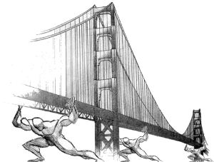

Real-time Bridge Monitoring
Guide to Inputs Conversion & Formulas calculation
Index
1.Type of Inputs 2
2.Content of Inputs 3
2.1.Analog files 3
2.2.Echo Sonar files 4
3.Conversion operations on inputs 4
3.1.Anemometer 4
3.2.Hydrometer 4
3.3.Sonar 5
4.What kind the calculations are there to do? 5
4.1.Anemometer (10min) 5
4.2.Hydrometer (10min) 6
4.3.Echo Sonar (10min) 6
4.4.Images 6
5.Calculation of Forcing 7
5.1.Stack / Cell compositions 7
5.2.Push of the wind 7
5.2.1.Effective speed 7
5.2.2.Push of the wind on the planking 8
5.2.3.Push of the wind on the traffic 8
5.3.Hydrodynamic thrust (on the whole stack) 9
5.3.1.Water speed 9
5.3.1.1.Scale of flow rates 9
5.3.1.2.2D Analysis 9
5.3.2.Water Thrust 10
5.4.Weight of the structure (of the whole stack) 11

Type of Inputs
here are three inputs:
- analog*********.txt → in this txt file there are the values measured by the Anemometer and the Hydrometer
- sonar**********.txt → in this file there are the values measured by the Echo Sonar
- Modean[Mantova]********.jpg → there are the pictures taken by the two camera

How to interpret the ID/timestamp of a file
analog*********.txt  sonar**********.txt | For this two kind of files the ID represents the Labview encoding and corresponds at the number of seconds that have elapsed sing 1th January 1904, without time zone so on the meridian of Greenwich (and at the same way for the timestamp of the all values in the file)  http://www.ni.com/white-paper/7900/en/  (there are 2 file (.xlsx & .ods) on GitHub [DSD/Data Source] that do this conversion automatically, just insert the number of seconds in the cell)
Example  File: analog3383680299.txt  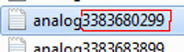  (fig. 1) | s = 3383680299 ← fig. 1  m=(3383680299 / 60) = 56394671  h = (56394671 / 60) = 939911  d = (939911 / 24) = 39162  y = (39162 / 365) = 107  rest of days = d - (y*365)=107  rest of hours = h - (d*24)=23  rest of minutes = m - (h*60)=11  rest of seconds = s – (m*60)=39  The rest of days is 107, and it's corresponds at the month of April because 107 is between the sum of the days till March(that is 90) and the sum of days till April (that is 120). So mean that 107 days remaining corresponds at the month of April, the 4th.  How many days in April? Easily April begin after 90days so 107-90=17days elapsed.  Ok, here we are:  Day 0 + results  y = 1904 + 107y = 2011  m= 0 + 04m = 04  d = 0 + 17d = 17  h = 00 + 23 = 23 h  m= 00 + 11 = 11 m  s = 00 + 39 = 39 s  At the end we have converted 3383680299 → 2011/04/17 at 23:11:39 on meridian of Greenwich, so for Italy, Sweden and Croatia time (UTC+1) just add +1h at the time to have to correct one.
Modean[Mantova]********.jpg | For the pictures the ID represents the exact date and time when the picture is taken
Example  File: mantova11032216564100.jpg  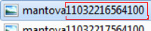  (fig. 2)  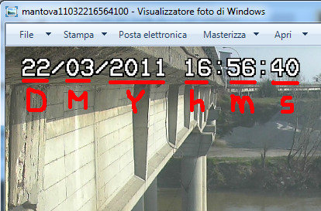(fig. 3) | As you can see in fig. 3 this picture is taken on 22/03/2011 (DD/MM/YYYY) at 16:56:40 (hh:mm:ss)  So this information are used to build the timestamp of the file, in this way:  Y = 2011 → 11 take only the last two number of the year  M= 03  D = 22  h = 16  m= 56  s = 40  concatenating all these numbers we obtain:  Y|M|D|h|m|s  110322165640  So if we compare this result and the file ID  110322165640 ← concatenation of values  11032216564100 ← timestamp of the file  is the same value except for the last two numbers that we can discard  As you can see, this file was saved just 1sec after the picture was taken.  Concluding, we can extract the date&time when a picture was taken, just reading the file ID.

Content of Inputs

Analog files
The analog file contains 4 columns of values (fig.4):
- Wind speed (unity measure mA)
- Distance between the Hydrometer and the level of water (unity measure mA)
- Wind direction (unity measure mA)
- Timestamp of the detection of the sample (Labview encode → see before)[decimals can be dropped]
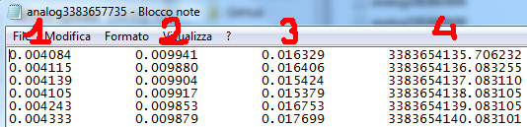

(fig. 4)

Echo Sonar files
The sonar file contains 2 columns of values, offset of a line (fig.5):
- Distance between the sonar and the bottom of the river (unity measure meters)
- Timestamp of the detection of the sample (Labview encode → see before)
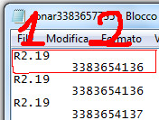

(fig.5)

Conversion operations on inputs
Every hour the system receives a packet in which there are an analog file, a sonar file both with 3600 values and two images, one for camera. All these values are to be converted from the parser into the db, in the table of Raw_data(1sec). Each values has to fill one row of the table.

Anemometer
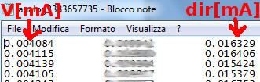
(fig.6)

- Speed →
- Direction →

Hydrometer
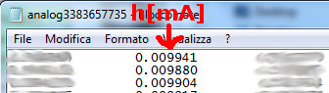
(fig.7)

- Distance hydrometer-water →
- Water height →

Sonar
For the sonar is a little bit more complicated because the sonar can produces five different kind of data.
- Correct data → Rxx.xx (can exist even one decimal)
- Uncertain data → Rxx.xxE (can exist even one decimal)
- Wrong data → xx.xx (can exist even one decimal)
- Sonar out of water → R99.99E
- Error → E1 or missing data

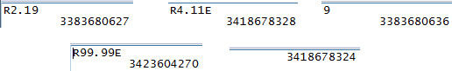

(fig.8)
The generic xx.xx is the distance in meter between the sonar and the height of the bottom.
- Height of the bottom →

Data that are of type ① and ② can be convert in a real height; for the other types this conversion is not possible but is necessary to store these information anyway, to compute some statistics that will explain later.

What kind the calculations are there to do?
To aggregate data for 10 minutes we have to manage 600 data as a single sample to calculate the needed information.

Anemometer (10min)
- [ANE1] mean wind speed
- [ANE2] maximum wind speed in the 10 minutes
- [ANE3] mean wind direction
- [ANE4] direction of the maximum wind speed in the 10 minutes

Hydrometer (10min)
- [IDRO1] mean water depth/water height
- [IDRO2] variance of the sample

Echo Sonar (10min)
- [SONAR1] mean value of the height of the bottom (only with data of type ① + ②)
- [SONAR2] variance of the sample (only with data of type ① + ②)
- [SONAR3] % of data of type “① + ②” used compared to the 600 elements of the sample
- [SONAR4] % of data of type “③” there are in the sample
- [SONAR5] % of data of type “④” there are in the sample
- [SONAR6] % of data of type “⑤” there are in the sample
- [SONAR7] % of data of type “②” there are, considering as sample the “① + ②” set of data (so not all the 600 data)

Images
The images don't need any kind of elaboration, they have only to be displayed.

Calculation of Forcing
For the most of the formulas, is needed the use of parameters; these parameters are in a db table that only who have a high level of authorization can change. The change of parameters causes the re-elaboration of the all data in the grouped tables (customers know it and accept it).

Stack / Cell compositions
The bridge is supported by various stacks/cells (call as you want, we have to choose and agree on one word) and each stack is composed by two line of three pylons connected together by a “pulvino” (fig. 9).
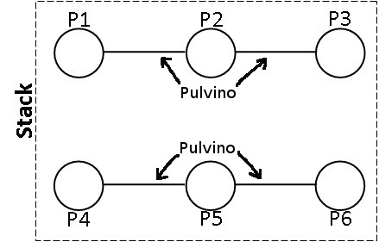
(fig.9)
The system has to calculate the forces acting on the stack and after, if is possible, has to divide these forces on the two lines of the stack and divide again on the three pylons of each line.

Push of the wind
The push of the wind is divided in two components:
- SVplank: is the push of wind on the planking.
- SVtraf: is the push of wind on the traffic.
Because the traffic is not monitored, we have to use a combinations of possible traffic scenarios; In this model were modeled three scenarios, named A1, A2 and A3.

Effective speed
Before start to calculate the push of the wind on the whole bridge system, we must consider the real relevant value of the wind speed and not the general one. Is defined effective speed (VEFFwind) the wind component orthogonal to the bridge and to calculate it are needed:
- Measured wind speed → [ANE2]
- Measured wind direction → [ANE4]
- Planimetric inclination of the bridge from the north → α (parameter)

Push of the wind on the planking
For calculate this value are needed these information:
- “Drag planking” coefficient → CDwi (parameter)
- Air density → ρ (parameter)
- Planking area → A_{PLANK} (parameter)
- Effective wind speed → VEFFwind (see previous point)

Push of the wind on the traffic
For calculate this variable we must consider the three possible traffic scenarios, and also are needed:
- “Drag traffic” coefficient → CDwi (the same of previous point)
- Air density → ρair (the same of previous point)
- Surface of traffic → ATRAF (parameter)
- Aerial reduction coefficient → β₁ or β₂ (parameters)
- Effective wind speed → VEFFwind (see previous point)

For traffic combination A1:

For traffic combination A2 (the same of A1):

For traffic combination A3:

Hydrodynamic thrust (on the whole stack)
The water pressure on the stack depends on the presence or not of debris on the stack basement
As the same way of the wind, will be calculate all the thrust and then choose at a later which consider.

Water speed
The hydrometer measures the height of the water, then we have to find a relation between the height of water and the water speed. To do this are needed:
- Scale of flow rates: correlates univocally the water height (hwater → [IDRO1]) and the flow rate (Q).
- Bidimensional analysis: allow to know for some flow rate value (Q) the relative value of water speed (Vwater)

Scale of flow rates
The following table show the relation between the flow rate (Q) and the water height (hwater). Depending on the value of hwater the parameters ai, bi and ci changes.
- a1, b1, c1 (parameters) for hwater < 17m
- a2, b2, c2 (parameters) for 17m < hwater < 22m
- a3, b3, c3 (parameters) for 22m < hwater < hMAXwater

Scale of estimate flow rates with fixed section
Parameters | [IDRO1] < 17m | 17m <[IDRO1]< 22m | 22m < [IDRO1] < hMAXwater | hMAXwater = 25,3m
ai | 46 | 60 | 96 | 96
bi | -902 | -1350 | -2800 | -2800
ci | 4658 | 8000 | 22500 | 22500

if hwater > hMAXwater the river has overflowed.

2D Analysis
The relation between the flow rate of water and its speed are in the following table. Depending on the flow rate of water, you can identify the range and interpolate linearly to get the speed of water.

2D analysis – fixed bottom
hwater [m] | Q [m³/s] | V_{water} [m/s]
3 | 510 | 0,24
10,5 | 5400 | 2,73
14 | 10000 | 3,54

N.B.: the parameters a,b and c are different from the parameters a_{i}, b_{i} and c_{i}

Water Thrust
To calculate the water thrust are needed these information:
- “Drag planking” coefficient → CDwa (different parameter from that of the wind, see below)
- Water density → ρ (parameter)
- Stack area → Astack
- Water speed → Vwater (see point before)

The “Drag planking” coefficient depends on the presence (D=1) or not (D=0) of debris on the stack base. So the Drag Planking coefficient is splited in:
- “Drag planking” coefficient (D=0) → CD0wa (parameter)
- “Drag planking” coefficient (D=1) → CD1wa (parameter)

The area of the stack invested by the flow of water depends on three factors:
- Presence (D=1) or not (D=0) of debris on the stack basement
- Height of the water → [IDRO1]
- Height of the bottom of the river –> [SONAR1]
- Shape of the stack; with presence of debris the shape of the stack changes, because the debris offer a greater surface on which the water can push.

The area of the stack is calculated using always the same formula, but depending on the scenario the coefficients involved change.

The hs is calculated independently by the presence or not of debris:
- [SONAR1] < bottom_ref → hs = [IDRO2] - bottom_ref
- [SONAR1] > bottom_ref → hs = [IDRO2] – [SONAR1]

The bottom_ref is a parameter.

The Bs, depends instead on the presence or not of debris:
- D=0 → Bs = Bs0 = c
- D=1 → Bs = Bs1 = 2*Dpylon

c and Dpile are parameters

At the end we have this formulas:
(D = 0) | (D = 1)

Weight of the structure (of the whole stack)
In this case we have to calculate the weight of the stack and the portion of palking which is competence of the stack. Most of the weight that will be considered are constant, the only variable is related about the portion of the stack exposed, so that portion that is above the height of bottom of the river measured as [SONAR1].

To calculate this value, are needed these information:
- Load on the stack → Ps (parameter)
- Weight of pulvino → Ppu (parameter)
- Weight of trunk pylon → Ptp (parameter)
- Weight of the beam → Pb (parameter)
- Weight per meter of the single pylon → Pp (parameter)
- Height of the beam → hbeam (parametro)
- Height of stack portion exposed → to be evaluated with [SONAR1]

Shifting weights / Mobile loads (traffic)

